Event

INCREASING TOURISM POTENTIAL OF THE KHARKIV REGION THROUGH THE EVENT TOURISM DEVELOPMENT

CONTENTS

INTRODUCTION………………………………………………….......……….…….2
1. MARKET RESEARCH ON THE NEEDS IN VARIOUS EVENTS………...........5
2. PROJECT “KHARKIV – THE CITY OF EVENTS”…………….........................13
3.THE EFFECTIVENESS OF THE PROJECT “KHARKIV – THE CITY OF
EVENTS” ………………………………………………………………………….20
CONCLUSION….………………………....…………………………………....……36
REFERENCES………………..….………………………………...…………………37

INTRODUCTION

Hosting special events has become an important element in cities and regions’ strategy in order to attract visitors and investments, provide a major boost to the tourism sector and turn into a major contributor to improve the destination competitiveness. In conditions of the necessity to increase the tourism potential of Ukraine to attract inbound tourists, understanding of the notion of event tourism and the way it functions, is becoming increasingly important.
Kharkiv that has a great infrastructure with its stadiums, squares and open air areas, only recently started to create its history of music festivals. A few festivals of different kind are held in Kharkiv: the modern music inherited after Bob Marley and the classic sounds of violin, piano and opera singing.
International Music Festival “Kharkiv Assembly” – the only Ukrainian international festival focused exclusively on classical art. The basic idea is to rase knowledge and integration of Ukrainian music into European space. It has a relatively large story having originated in 1991. The festival welcomes conductors and violinists from Spain, Switzerland cellists, singers from Germany and France, pianists, flutists, tenors, harpists, a symphony orchestra and choir. Within two weeks of the festival, it is possible to listen to the sounds of many orchestral classical works and their modern interpretation.
In the same line with music industry are sport activities. Тational tourism is quite developed already: football fans are attending matches of their favorite teams; athletes and just sport lovers participate in some yearly hold events such as marathons etc.
Moreover, some of the yearly events, which are appreciated by the Ukrainians, are marathons and bicycle days. First Kharkov Marathon of the year 2014 attracted more than 10 thousand people and was put into the Ukrainian Book of Records as the most popular race in the number of registered participants. After this event, Kharkov even began to be called a Ukrainian running capital. The purpose of the event is to promote running in Ukraine, combining professional runners, amateurs and beginners from all over the country and so far, everything is going so. Kharkiv is a cycling city, every year in Bike Day participates from 10 to 15 thousand people. In addition, mini cycle track from “Veloplaneta”, the BMX competitions, building bike figures, track stand, children's area and a variety of competitions are organized.
Besides the main events, a food festival “City Picnic” as part of the project “Urban Picnic: Food Festival” to promote both local businesses and different national dishes is regularly organised.
The issues of event tourism development, in the world practice, have been studied by such scholars as D. Getz, C. Formica, M. Hall and others. Certain domestic scientists have also contributed to the subject of study, particularly: A.G. Zima, A.V. Babkin, G.P. Dolzhenko etc.
The purpose of the paper is to create a project for increasing tourism attractiveness of Kharkiv through event tourism development. Precisely, to identify target segments and their requirements for the destination for the further development of the project and revealing the ways of implementing it for the use at the international level.
The practical significance of the paper is implementation of the project “Kharkiv – the city of events” to create a positive city’s image, increase tourist flows, improve economic and social activity and establish international relation

- MARKET RESEARCH ON THE NEEDS IN VARIOUS EVENTS

Marketing research is the function that links the consumer, customer, and public to the marketer through information. This information is used to identify and define marketing opportunities and problems, to generate, refine, and evaluate marketing actions, to monitor marketing performance and to improve understanding of the marketing process [18]. Marketing research specifies the information, manages and implements the data-collection process, analyzes the results, and communicates the findings and their implications.
A well-conducted research allows to determine whether the company or organization has been able to satisfy its customers or not. It provides crucial information about the various factors, which affect the business. It helps to formulate plans, take necessary measures, and evaluate performance. Moreover, market research is not just for those who are already in business. If someone intends to start afresh, it is as important as it is for those who are already set. To start with, it will help to identify opportunities available in the market and make the most of them. It will also give the ability to identify and tap potential consumers by dividing the market into various segments – on the basis of age, gender, geographic area, etc – and cater to their needs, thus making the most of the available resources. That is why, to define the best way of developing event tourism in Kharkiv region and use all its resources more effectively, the survey on customer needs in events was conducted.
For conducting this particular research the primary method, that is usually carried out for the specific purposes or for the previously unknown area, was used. Moreover, both quantitative research that produces numbers and figures – such as numbers and percentages of consumers who are aware of particular products or

services and qualitative research, which on the other hand, provides data on why people buy – what motivates them to buy – or their impressions of products, services or advertisements, were used. The problem of the research, its objective and hypothesis that will be confirmed or refuted, were defined.
The problem of the research is that Kharkiv does not use its potential in developing event tourism.
The objective is to find out the preferences of potential attendees of events and build up the picture of customer portrait to most popular types of events.
Several hypotheses were outlined:
people are unaware of what event tourism is; majority of people attend events few times a year;
people are more interested in the big events of world scale; the most popular events are of entertainment character;
people are unwilling to travel somewhere to attend some event.
Research contact method was used and through e-mails, publication of questionnaire form in different social media and personal interviews, 159 people were surveyed. The questions proposed were of different form: from closed with different options to open ones. They were also of diverse nature, bringing out the general information and each person’s preferences due to the subject of survey.
The first question was “one out of two” and directed to identify the gender of respondents (Figure 1.1.).

38%
62%
Woman Man

Figure 1.1. Respondents’ gender

Gender is an important factor, while with understanding it we would be more aware of a list of things, such as type of the most appropriate advertising, time slot for TV channeling, as the preferences differ greatly depending on gender.
According to the results of survey, the vast majority of those who participated in it were women. That does not give a right to make assumption that they are more interested in events, but it should be agreed that the results of survey would be by 24
% more oriented on the women choices.
The next question was to differentiate age groups as it is one of the main factors that shows the distinction of preferences (Figure 1.2.). It is obvious that a teenager would prefer some entertainment event rather than business or political ones and that the older people would enjoy more some cultural events. Of course, it also depends on a number of other factors, such as sphere of interests, hobbies etc. but age is an integral part to build this picture of preferences.

60&older 16%
up to 16
16%

40-60
22%
16-24
24%

25-40
22%
Figure 1.2. Age groups

In the survey, the major part constituted the people of age 16 – 24 in total amounted to 38 person, with the equal amount of respondentsof the age groups of 25 – 40 and 40 – 60. The least number of respondents were classified to the age up to 16 and 60 and older. This classification relates to the next question about a future picture of what duration and orientation every particular event should have. Moreover, it was important to understand the place of respondents’ residence as it showed the part of potential national tourists who, according to next questions, expressed their willingness to visit Kharkiv with the purpose of attending some event (Figure 1.3.).

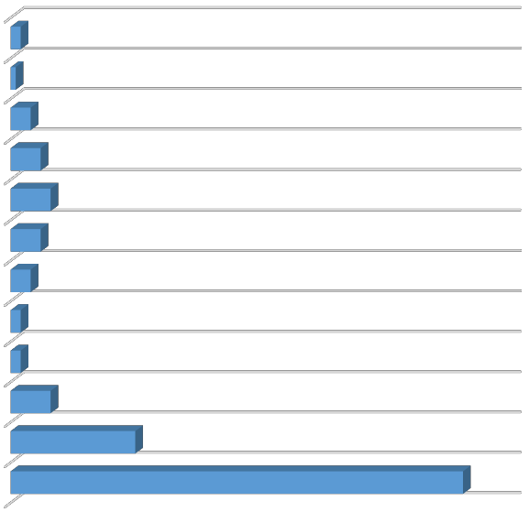
C R IM E A C H E R K A S S Y KH E R S O N
1
4
6
8
6
4
2
2
8
25
91
S UMY P O LTAVA O D E S S A
LV IV Z A P O R O Z H Y E D O N E T S K
D N IE P R O P E T R O V S K
KY IV
KH A R K IV

Figure 1.3. Place of residence

Due to the factor that survey was conducted in Kharkiv region the biggest part of the respondents, more precisely 57%, were residents of Kharkiv, and due to some online questionnaire we received the opinion of people from other regions with the greatest return from Kyiv with 16%. The answers on this question show that the results of our survey will be built on the opinion of more than half of Kharkiv residents and 43% of other cities, that makes events that would be organized due to conclusions of this worksheet oriented primary on its residents and then on potential national tourists.
Another question is on a choice of several options and directed to the understanding of how people prefer to spend their free time. The variant of attending various events was added to show how many respondents are already not only interested in events but are their part. Another reason of this question – is to define the scope of activities that people prefer and that could be potentially replaced with some event (Figure 1.4.). The results show that attendance of events takes only 11% of preference to other activities and that 27% of respondents are already a part of event

industry with 43 positive answers. In addition, the indication that most of respondents are rather spend their free time at home, attend some entertainment venues or do sports, gives us an idea that with the right motivation they could choose to change their usual activity and make a decision to attend the event. As for those who spend their free time at home, we have all the levers to push them for participation in some event through advertisement on TV and Internet. For those who attend entertainment venues, it would be rather effective to promote some film festivals, concerts etc. with the help of booklets and posters placed in those venues. In addition, for those who do sports, the promotion of recreational events in some gyms and other sport related establishments would be worthwhile.

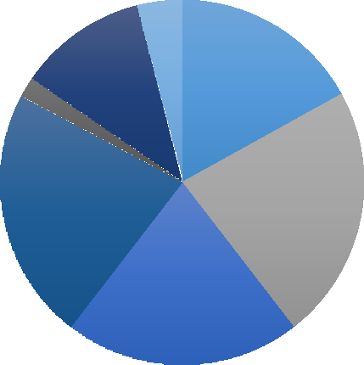
Do sports
4%
11%
2%
17%
22%
23%
21%

Spend time at home (reading
books, watching movies) Go for a walk

Attend entertainment venues (cinemas, game centers etc.) Attend excursions

Attend various events (concerts, fairs, festivals, sports, etc.)
Do not have free time

Figure 1.4. Free time activities

Then the respondents were asked where they spend their holidays and vacations. This is important to know in order to understand whether the people stay in the city or travel somewhere and gives us an idea of relevance of organizing events during holidays, as despite the most wanted visitors are not residents, the great part of event success and payback depends on them (Figure 1.5.).
As a result, it is clear that the biggest part of respondents stay in the city or in its suburbs, that indicates that it would be easier to convince them that attending event is

a great alternative of how to spend the holidays. What is more, the figures show that people are travelling around the country during vacations, and with the great part of them from Kyiv, gives a thought of possibility to attract native tourists to events held in Kharkiv.

9%
16%
31%
16%
28%
Stay in the city
Travel outside the city Travel around the
country

Go abroad (in countries with free boundaries)

Go abroad (in countries requiring visa)

Figure 1.5. Places, where respondents spend holidays and vacations

Understanding the awareness of people of the particular type of tourism that we are willing to develop is also rather significant. As knowledge about some product or service is already a fifty percent of the marketing campaign success (Figure 1.6.).
38%
62%
yes
no
Figure 1.6. Awareness about event tourism

Unfortunately, most of the respondents, precisely 99 of them, are unaware of what event tourism is. It does not show the willingness or opposite of people to attend events, but it requires to promote it as a concept, not only as a reason for holding a particular event. That means that only when people would be fully aware of this notion, they would search for it on purposefully and tour operators, agencies, those who sponsor events would see the real possibilities to profit from event tourism development.
The frequency with which people attend events provides a certain picture of a periodicity when events should be hold to attract more visitors (Figure 1.7.).

a few times a week a few times a month a few times a year rarely
6% 6%
18%
29%
41%
do not attend at all

Figure 1.7. Events’ visit frequency

As survey shows, 41% of respondents attend events a few times a year and 29% a few times a month. According to it, a conclusion can be made that in order to attract a lot of attention to each event, it is better to organize near 3 – 4 events a year. Nevertheless, it is more about hallmark or mega events that seek for much attention to get success. Those of regional and local character – more of business, educational or political character – could be held more frequently as they strive not only for a smaller number of attendees, but also have rather different target audience than entertainment and cultural events which even on a small-scale require involvement of a great part of population.

The next question is related to the scale of events (Figure 1.8.). It is rather important to understand the difference between these four types of events and therefore to know in which people are more interested. Each type requires different level of preparation due to venue type, status of participants, media involvement, number of sponsors, marketing expenses etc.

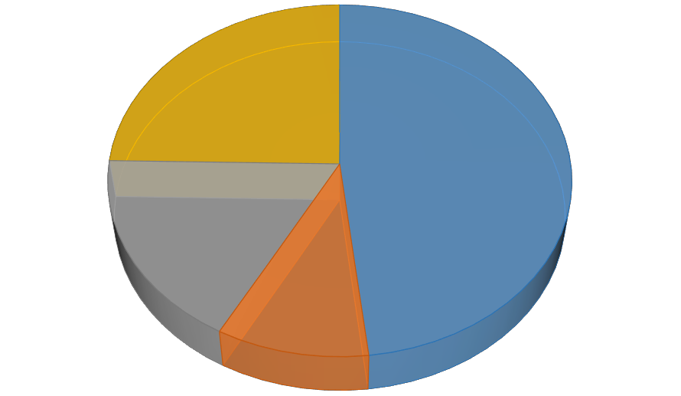
Regional 10%
Hallmark 17%
Local
48%
Mega-events 25%

Figure 1.8. Scale of events

Rather surprisingly, respondents prefer to attend some local events with 48% preponderance. Maybe this happens due to unknowingness of the definitions and a wrong idea that only local events are held within the city, but it is a fact. Therefore, the plans for holding some events should be based on understanding that respondents prefer events of a local scale. Nevertheless, the thought of bringing them to international level and transformation to hallmark type should not be forgotten as only they and mega events can contribute to the development of not only national, but also international tourism.
The following question is critical to build a picture of events that would be popular on the market. The type of event is the best way to describe the direction and concept that event should take. As to the general qualification of event types respondents were asked of their preferences, being able to choose a few at once The results are displayed below, in the Figure 3.9. The chart shows the prevalence of some

events over others, rather than percentage of interviewees, who choose one or other event type.

4%
12%

24%

5%

37%

9% 19%

9%
Cultural (festivals, carnivals,
religious events)
Entertainment (concerts, award ceremonies)
Sport events

Political events (summits, the arrival of political persons, etc.)
Education and scientific

18%

Business (fairs, trade shows,
etc.)
Recreational (sports events and games for entertainment)
Private events (weddings, parties)
Figure 1.9. Types of events

The major part of respondents showed their interest in entertainment, private and cultural events with 59%, 47% and 46% correspondently. Most of those who have chosen entertainment, showed their interest also in cultural events, those who marked business events also chose education and scientific events, sport and recreational were also most of the time connected. Nearly each second person has chosen private events as they are the most natural types of events that people attend even if they are not so interested in them. The interest in political events was showed rather purely – only 10% willing to attend them. This division could build up the picture of target groups being the primary factor that have influence on people's choice.
The knowledge of whether people travel to other city or country to attend the event is important for evaluating prospects of event tourism development on national and international level rather than only local (Figure 1.10.).
The better part of respondents answered negatively to the question, but on the other hand, expressed their willingness to do it. All in all, summed up the answers of

those who already participated in events that were held out of their permanent residence and those who would not mind to travel for it, we received the prevailing majority with 84%. It means that potential of developing event tourism in Ukraine and Kharkiv is high.

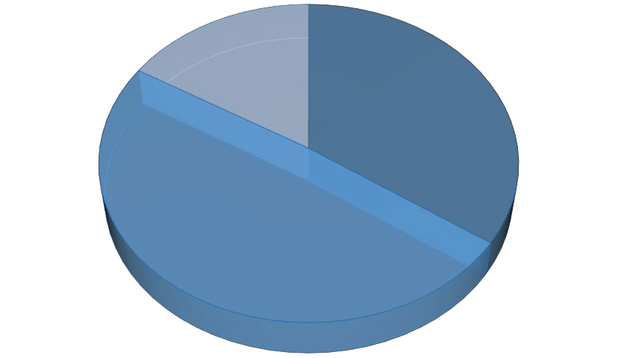
no, but could / would like to
49%
yes 35%
no
16%

Figure 1.10. Travelers to other city/country for event

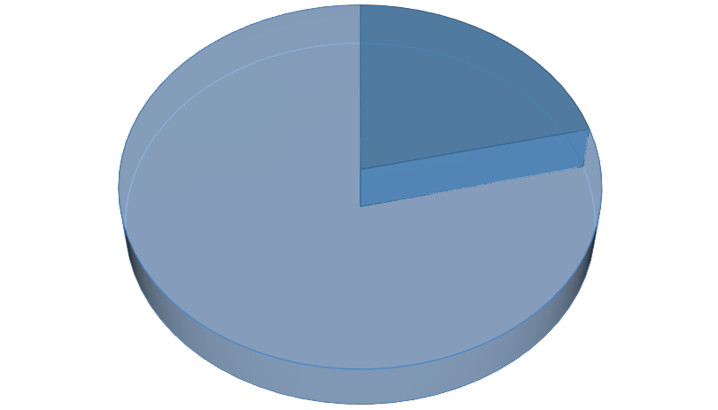
The factor that does not directly influence the success of event or this particular type of tourism, but shows the potential for development of other types alongside with it, is the fact if the respondents just attend the event and leave or stay and take the possibility to explore another city or country (Figure 1.11.). The answers to this question were received only from those who answered the previous question positively.

Attend the
event and
left
21%
Used the
opportunity
to see the
sights
79%

Figure 1.11. After-event activity

What is more important for this survey rather than the amount of people, who have a desire to attend an event, those who are willing to attend particularly Kharkiv events. That is why respondents were asked to answer whether they have already visited some Kharkiv events or not (Figure 1.12.). Besides, it helped to understand the current state of event tourism development of the region and its potential.
To sum up the results, a greater part of respondents have attended events in Kharkiv city. From those 67% who answered positively were also 35% from the total amount of non-Kharkiv citizens. As the next question shows, most of them have visit the city while Euro2012 or concert of Queen. Moreover, only eight respondents from Kharkiv answered negatively, most of them of age up to 16.

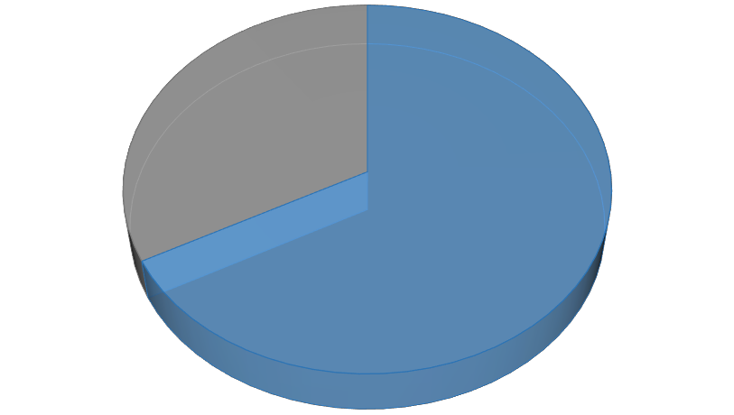
yes 67%
no 33%

Figure 1.12. Attendees of Kharkiv events

The next question was open and the results presented in the chart sum up the most frequent answers. People were asked of the most memorable events that they have visited in Kharkiv (Figure 1.12.). It was aimed at defining which already held events were successful and have the potential for further development.
The prevailing quantity have mentioned Euro2012, a mega-event with sport orientation. It is not surprising, as it is the most recent big event that is still in minds of all its visitors. The second and third place took City Day and concert of Queen correspondently. The concert drove attention not only because of the world known

group, but also because of its aim to fight with AIDS. It received a lot of attention from media, and people were discussing it long time after the event had finished. City Day is the yearly held celebration that gathers all Kharkiv citizens on its big square to celebrate its independence. The celebrations are not the same, every year different activities are proposed, but it is always full of music, fireworks and love to the motherland.

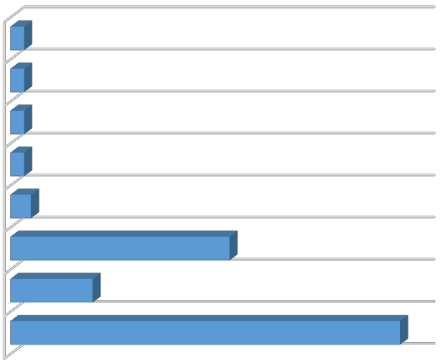
HO L I F E S T IVA L
2

2

2

2

3
32
12
57
M A R AT H O N M U S IK F E S T IVA L KAYA K FE S T
V ELO D AY
C IT Y D AY
Q U E E N
E U R O 2 0 1 2

Figure 1.12. The most memorable Kharkiv events

Other events were mentioned rather seldom, maybe due to their scale. Nevertheless, Marathon and Velo Day are events that drive more and more attention not only from Ukraine, but also from abroad. Holi festival, that is popular all over the world, has as well received appreciation, especially by teenagers who really enjoyed the celebration of paints and freedom.
The last question was about events that respondents want to visit (Figure 1.13.). The reason for it is to research the potential events, which could be hold in Kharkiv or some alternative to them that will also interest people.
Eurovision and Football World Cup were mentioned most frequently, and despite the fact that it is impossible for Kharkiv to host the second event, the first one due to the previous events is rather likely. It is already known that next year Ukraine will host this event thanks to Jamala’s victory, and Kharkiv could fight the opportunity to held it from Kyiv and other cities. As for the Olympic games that received 8 votes, it is also unlikely in the nearest future, but the alternative that could also attract

attention is Small Olympic Games, the practice that has spread throughout the world. Another niche after sport takes music, concerts and festivals as they were chosen by 40 respondents. The most popular among them are jazz festivals and concerts of Ocean Elzy and Mot. Some gastronomic festivals and carnivals could also become popular.

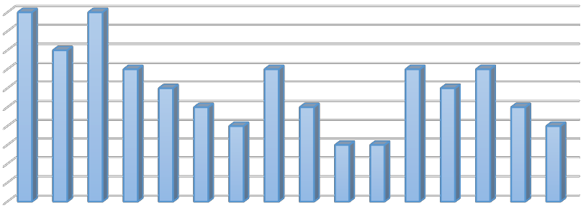
10
10 10
8
7
6
5
7
7
4
5
6
7
3 3
5
4
9
8
7
6
5
4
3
2
1
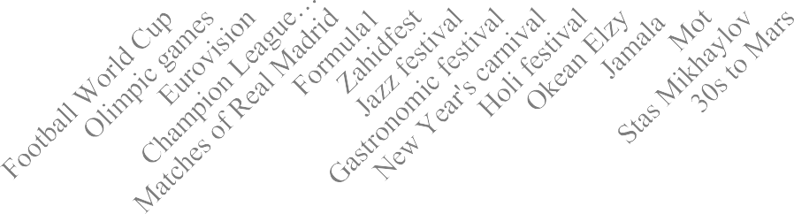
0

Figure 1.13. Events that people want to visit

All questions were analyzed and some hypothesis were proofed and some refuted. The first one about that people are unaware of what event tourism is, was proofed as only 38% of respondents showed their knowledge. That leads to the fact that its development could take a longer process as firstly, both those organizations that could be involved in creation of event tours and those who are potential visitors of events, should be informed of the basic ideas about it and the benefits it will bring to them.
The second one – on the frequency of event attendance – was also proofed, as almost a half of respondents, 41%, said that they attend events a few times a year. As it was already mentioned, it gives the picture of how often and with what periodicity events should be held. Another hypothesis that people are more interested in the big events of world scalewas refuted. The respondents showed more interest in local events with 48% of prevalence. This shows the potential success of events that will be

organized in Kharkiv and that initially will not be able to reach the international level. Nevertheless, with the support of local authorities, it may become possible in the future.
The fourth one was that the most popular events are of entertainment character was acknowledged. More than a half, 59%, chose entertainment events along with some other. This fact gives the direction to develop event tourism first of all in this sphere. And the last hypothesis that people are unwilling to travel somewhere to attend some event was refuted. 84% of respondents said they would rather have such experience or will be glad to have it in the future. This suggests that people are eager to travel with the purpose of attending an event that creates prospects for development of national and international event tourism.
This survey was aimed at understanding the potential market of event tourism in Kharkiv region and to use the results to build up the calendar of events for the coming year and target audience of each of it. This will be accomplished in the next part of this chapter.

- PROJECT “KHARKIV – THE CITY OF EVENTS”

Recently, more and more destinations have come to understand the potential of events in achieving different kinds of economical and tourism goals this is not to say that destinations and tourism organizations use events strategically. Every year a great number of different types of events that attract tourists take place in destinations and many new events are being planned or already on the way.
Firstly, events can be used as core attractions around which a destination can develop theming, image building and packaging. This type of strategy is appropriate for towns and cities, such as Kharkiv, lacking major tourism infrastructure. Accordingly, the way in which a destination positions itself is the result of one or more events and the theming that surrounds them. In this strategy, it is desirable that a destination possesses one or more events so that the images of these events and the destination become inseparable and mutually reinforcing.

A generic event tourism strategy that supposes availability of a variety in community events was used in creating the project “Kharkiv – the city of events”. Instead of trying to attract and create new and big events this strategy is based on existing and new community events. Furthermore, the strategy is built on authenticity, variety and strong community support to attract and satisfy tourists. The costs of this strategy are minor, however, extra effort will be needed to generate publicity and involve the tourist industry and to mobilize and facilitate the communities and interest groups to pursue tourism marketing.
The goal of the project is to achieve a good mix of events that will make the city more attractive.
Objectives of the project:
promotion of the direction “event tourism”, improvement of its investment attractiveness;
creation of a unified information database of the most interesting events (event calendar);
establishment of direct communication with professional associations and unions in the event, marketing, branding, tourism, regional associations of tourism, regional tourist information centers, in order to inform about the project as many professionals in the sphere of event tourism as possible and make an attempt of their involvement in the project as partners;
promoting public-private partnership mechanism in the field of event tourism.
According to our research, Kharkiv has knowledge and experience of arranging concerts and some other music events and that is why they are the most common type of events that are arranged and that drive the most attention of events attendees and visitors. Cultural events are also important for Kharkiv, especially carnivals and festivals that are directed at a large target audience. Nevertheless, we should stress that the city is not going to exclude anything, but believe that all kinds of events are important. The strategy of the project implies the development of already existing events that are held in Kharkiv with the frequency of once a year or in two years that

were described in previous chapter. Moreover, they all should be registered to one database, event calendar, and presented on the main sites related rather to the event sphere, tourism, or Kharkiv itself. Primary, they are http://omctur.kh.ua – the official website of the Kharkiv Regional Tourist Information Centre and http://www.ufest.in.ua – the most popular and developed site dedicated to the events held in Ukraine.
Moreover, the potential that Kharkiv has in holding some business, educational and scientific events should not be forgotten. It is due to its infrastructure and status of the students’ city with many educational institutions and organizations that cooperate with other countries and provide possibilities of exchange studies, and a business center with a number of large local enterprises and branches of international companies. The main venues that presents infrastructural base for developing mentioned types of events, are represented in the Table 2.1 [13; 14].

Table 2.1

Venues of Kharkiv

Venue | Conference  room | Area,m2 | Seats
Radmir Presentation and Exhibition Center | 1 | 1571,4 | 580
Spalah Creative Area and Coworking | 5 | - | 201
Nove Mistle Loft | 1 | 1540 | 100
Metalist Conference Service | 4 | 514 | 380
Telesens Business Center | 3 | 228 | 180
Proton Business Center | 1 | 232 | 250
Panorama Even Hall | 1 | 170 | 220
Premier Palace Hotel Kharkiv | 3 | 941,7 | 830
Superio Golf nd Spa Resort | 4 | 540 | 433
HotelMir | 2 | 303,7 | 200
BritaniaHotelandRestaurantComplex | 4 | 626 | 1070
DruzhbaHotelandRestaurantComplex | 3 | - | 580
DFSK LokomotivHotel | 2 | 1388 | 3300
V.N. KarazinKharkivNationalUniversity | 3 | 816,2 | 755
S. Kuznets Kharkiv National University ofE  conomics | 6 | 775,4 | 492
Yaroslav the Wise National Law University:

Table 2.1 (the end)

Pushkinska St., 77 | 7 | 1350,5 | 1377
Pushkinska St., 106 | 2 | 492,8 | 595
Dynamivska St., 4 | 1 | 105 | 100
Pushkinska St., 84 | 1 | 168,5 | 180
Pushkinska St. Palace of Students, 88 | 1 | 777,7 | 1269

So, two events, namely festivals, one dedicated to music and another one to the contemporary art, were chosen, which due to conducted survey could push the development of event tourism in Kharkiv, the programs of their activities were drawn up and the target audience for each of them was described.
At any rate, festival – is a huge event involving a large number of people, attracting media attention. That is why the organization of the festival is often used as an effective PR-campaign. In addition, festivals contribute significantly to the social and economic life of the region where they are held [11]. Realizing this, the local government strongly support the festival events, receiving considerable indirect profit from their realization. In order the organization of the event could bring the expected results, it is necessary to carefully prepare it, taking into account all the nuances. Besides, as it is a long and time consuming process, the stages of event organization should be clearly defined and strictly followed. In the table below, the average time of each stage duration is introduced (Table 2.2).

Table 2.2

Stages of event development

Date | Stage of development
in 6 month | Defining theme and format of the event
in 5 month | Ascertainment of date, venue and duration
Obtaining permission from the local
authorities
 | Determination of the target audience
in 4 month | Drawing up a clear plan of activities
in 3,5 month | Counting budget&attracting sponsors

Table 2.2 (the end)

in 3 month | The selection and invitation of participants
in 2 month | Providing advertising
in 2 weeks | Check preparedness of event
X-Day | Holding event
after X-Day | Collect the rewiews on event

StreamFest – is a Kharkiv modern music festival the main aim of which is to establish contacts, strengthening of inter-regional relations and cooperation through art of music, the formation of the creative potential of young artists as well as building a city image.
The main objectives of the festival are to:
attract tourists to the festival and economically benefit from it;
identify, support and promote young talented artists and creative groups in Ukraine and abroad;
establish dialogue in the field of professional communication, increase cultural ties, exchange experiences and discover new names;
promote the main tourist or related businesses of Kharkiv that sponsored the

event;

involve the mass media in pre and post event coverage.
Estimated date of the festival is the middle of July, while after analysis of already

existing festivals on the market that have music or other character, it was defined that while summer is the most appropriate season for holding open air music festivals most of them are held during June or August. That is why, for not to fight for visitors with events held throughout Ukraine, such decision was made.
For the location it was decided to take into account previous experiences in holding festivals in Kharkiv city and choose Bezlyudovka – a huge open air area in the suburbs of Kharkiv that is ideal to hold big events.
The target audience for participants of the music festival was defined. They are young artists and bands from around the world, but most from Ukraine. Mainly those

who have not yet received recognition in the music industry interested in and performing contemporary music in the styles of rock, pop, jazz and club. Those who seek the opportunity to be glorified, to find connections in the music industry and contribute to the development of music. Get their information from the internet, namely social networking, sites covering projects for music development, specialized sites dedicated to music etc. Make decisions based on the level of the competition and its scale, the future opportunities that it will bring, the first place prize, etc.
Moreover, the analysis of the target group for potential visitors of event was made. Regardless of gender, of age from16 to 40 years old, mostly from Ukraine and bordering countries. These are the people working in different fields, but who have some interest in music and festivals. Seekers for opportunity to differentiate their spare time. They get their information from the Internet resources, namely social networking, travel and news sites, from the publications of entertainment character, TV etc. Making decision based on the type and scale of event, its main and accompanying programs, the presence of invited stars, as well as measured costs for the period of event.
In the table below the main program of the music festival, which includes the contest between participants of event, is described (Table 2.3).

Table 2.3

The main program of the music festival

Date | Activity
Month before an  event | The first phase of the approval of the participants through videos
1st Day | Opening the event by famous artist (Mot, OE etc.) on the main  stage
 | The division of participants by the music type on three stages:
 | Jazz and Pop stage
 | Rock stage
 | Club stage
 | First perfomances with cover songs (12 participants on each stage)
 | Getting scores and announcement of finalists
 | Night program “Around the campfire” — free performances along with dances

Table 2.3 (the end)

2nd Day | Second round of performances (15 participants on each stage)
 | Getting scores and announcement of finalists
 | Night program with fire show and discotheque
3d Day | Perfomance of finalists with original songs ( 9 for every categorie)
Entertainment night program with contests and diverse
performances
4th Day | Announcment and awarding of winners
 | Gala consert with the perfomance of famous atists
 | Firework show

Alongside with the main activity, that is music contest, many other will be organized, so that everyone could find something interesting for him / her to spend time between performances or during them as everything will be placed in one area, so people could enjoy a few activities at the same time. Altogether, there will be five thematic zones (Table 2.4.).

Table 2.4.

Accompanying activities within music festival

Leisure section | Activity
Music zone | Learning to play various instruments
 | Music jams non-stop
Dance zone | Master classes on different dance styles
 | Dance battles
Foud court | Cuisine from around the world
 | Alcoholic and non-alcoholic beverages
 | Food eating contests
Art zone | Henna body painting
 | Fair of hand made
Artists' zone | Autographs sessions
 | Participants' CDs and attributes sale

InsideEye Fest – first festival of contemporary art in Kharkiv that would combine a number of different art forms, which will be united by one theme.

The aim of the festival is to organize a youth creative space for live communication, as well as to bring together the traditional culture with modern art.
The main objectives of the festival are to:
economically benefit for the city by attracting tourists to the event;
support the development of contemporary art and young artists in Ukraine; promotion of the main tourist and related businesses of Kharkiv that sponsor
the event;
involve the mass media in pre and post event coverage.
Estimated date of the festival is the end of April – beginning of May, while this is the perfect time to enjoy not only the festival, but also awakening surrounding nature. Moreover, this period is not loaded with other events, so there will be no competition at least on the national scale.The festival will last from five days to a week. As a location, it was decided to consider Height of Marshal Konev – a huge area with a beautiful nature in the suburbs of Kharkiv.
The target audience for participants of the festival is very diverse. They are young artists that perform in one of the art fields introduced on the festival. Those, who have not yet received recognition in the industry or are eager to promote themselves a little more. Interested in presenting their works of art made specifically for the festival and its theme. Those who seek the opportunity to find connections in the art industry and make their way to it. They get their information from the internet, namely social networking, sites dedicated to art, from the publications on art thematic etc. Make decisions without relying on monetary benefit, but based on the level of the organization and scale of festival, the future opportunities that it will bring, particularly contact in art sphere etc.
What is more, the analysis of target group for potential visitors of event was made. Regardless of gender, of age from16 to 60 years old, mostly from Ukraine and bordering countries. These are the people working in different fields, but who have interest in different art fields. Seekers for opportunity to differentiate their spare time and immerse themselves in contemporary art. They get their information from the

Internet resources, namely social networking, travel and news sites, from the publications of entertainment character, TV etc. Making decision based on the type and scale of event, its main and accompanying program, the presence of famous art performers, as well as measured costs for the period of event.
The main theme of the festival is going to be “The future I see” and will present the works of art from different fields to present this idea. More precisely the festival will introduce its visitors to cinematography, dramatic art, fine arts and photography. The main activities that will be held in the zones each dedicated to some art field presented in the Table 2.5.
Besides, the festival will have a food court that will present its own art of culinary. There will be music accompaniment and performances by some Ukrainian artists. What is more, on the last day the color festival analogy for Holi – Indian traditional annual celebration of spring and bright colors, will take place. There participants will play, chase and color each other with dry powder and colored water, with some carrying water guns and colored water-filled balloons for water fights.

Table 2.5

Main program of the festival

Art field | Activity
Cinematography | Short Film Competition
 | Open air cinema with old movies about the future
Dramatic art | Performances of Ukrainian and foreign theater groups
 | Acting master clases
Fine arts | Charity exhibition
 | 3D exhibition/photo zone
 | Master clases on hands and feet drawing
Photography | Charity exhibition
 | Photo sessions
Other | Pottery master clases
 | Hand-made fair

- THE EFFECTIVENESS OF THE PROJECT “KHARKIV — THE CITY OF EVENTS”

Evaluation of the effectiveness of the project is one of the factors of its success, as it is not only helps to understand its scope and needed resources, but also serves as a tool for attracting investments. Without representation of project benefits on both economic and social aspects, it would be hardly possible to find sponsors.
For organization of two events approximate expenses that include marketing campaign, tools necessary for particular events setting up and additional costs such as star guests for increase of event attractiveness were calculated and presented in the table below (Table 3.1).
Table 3.1

Approximate event expenses

Type of expenses | Approximate sum, UAH
Marketing campaign:
Production of promotional material (billboards, posters, displays, leaflets  etc.) | 100 000
Arrangement of advertisement on billboards | 25 000
Arrangement of external advertisement (transport, subway etc.) | 12 000
Creation of site-business card | 2 500
Promotion on other sites | 8 000 (partly free for partners' sites)
Website promotion in search engines | 7 000
Event promotion in social networks | 14 000
Advertising on radio | 12 000
Launch of commercial on television | 150 000
Event press coverage | 25 000 (partly for  free)
Event facilities | 800 000
Invitation of famous artists | 3 000 000
Prize fund | 80 000
Total | 4 235 500

As TIC that is going to lunch the project – is a non-profit institution and could not handle the organizational costs of events by themselves, there is a need of finding sponsors. That is why the market of Ukraine and particularly Kharkiv on the potential sponsors that could benefit from holding event was analyzed (Table 3.2).

Table 3.2

Potential sponsors of Kharkiv events

Sponsor | Sphere | Potential  investment
Hotel Kharkiv Palace | Accomodation service | Platinum sponsor
Hotel Chichikov | Accomodation service | Gold sponsor
Superior Golf & Spa Resort | Accomodation and entertainment service | Platinum sponsor
Iris Art Hotel | Accomodation service | Silver sponsor
Complex Nemo | Accomodation and entertainment service | Gold sponsor
Nasha Datcha | Accomodation service | Gold sponsor
Gorky Park | Game and entertainment  center | Platinum sponsor
Misto | Entertainment complex | Gold sponsor
Radmir | Night club | Gold sponsor
Holiday | Night club | Silver sponsor
Arizona club | Night club | Gold sponsor
Sindikat vkusa | Restaurant chain | Gold sponsor
Stargorod | Food and entertainment  service | Gold sponsor
First Line Group | Restaurant chain | Platinum sponsor
Red Bull | Beverages | Platinum sponsor
Lvivske beer | Beverages | Gold sponsor
MTS | Mobile connection | Platinum sponsor
Life | Mobile connection | Platinum sponsor
Annex Tour | Tour operator | Gold sponsor
TEZ Tour Ukraine | Tour operator | Gold sponsor
Akkord Tour | Tour operator | Platinum sponsor

It is natural that some organizations are able and willing to invest more than others and vice versa, that is why it is important to differentiate sponsors according to their monetary contribution and distinguish them according to promotional tools they

will be able to use. Below, in the Table 3.3, different options due to which four types of sponsors, from platinum with the highest fee to flow sponsor with the lowest fee, are described.

Table 3.3

Sponsorship packages and their possibilities

Options | Platinum sponsor | Gold sponsor | Silver sponsor | Flow sponsor
Providing with status | ✔ | ✔ | ✔ | ✔
Company logo on event website with a link to their website | ✔ | ✔ | ✔ | ✔
Company logo on promotional  banners | ✔ | ✔ | ✔ | ✔
Logo placement in print and electronic materials | ✔ | ✔ | ✔ | ✔
References to the company name in dispatches | ✔ | ✔ | ✔
Mention of the name of the company when opening and closing event | ✔ | ✔ | ✔
Placement of promotional products in the areas of entertainment | ✔ | ✔
Promotional video show during the break between perfomances (up to 2  min.) | ✔ | ✔
Contests and promotions in the exhibition area | ✔ | ✔ | ✔
Company's stand placement | ✔ | ✔
Discount for event related activities | 15% | 10% | 7% | 5%
Price | 90 000 | 70 000 | 50 000 | 22 000

In accordance with the previous experiences of holding festivals in Kharkiv and Ukraine it was suggested that the music festival that lasts for four days will be attended by near 1 000 000 people with 40% of national and international visitors. As for the festival of contemporary art that will last up to 5 days the prediction is 400 000 visitors with 60% not Kharkiv residents.

Due to this information, the cost of each attracted tourist was calculated: Expenses per visitor = Total expenses/Amount of visitors (3.1)
Expenses per visitor = 4 235 500/ (1 000 000+400 000) = 3, 03 UAH So, the approximate costs were defined:
the average price for accommodation facilities in Kharkiv amounted to 490 UAH per night;
the average bill in a restaurant - 175 UAH;
cost of additional services such as snacks and drinks, souvenirs and cost of master classes amounted to 600 UAH per person with a variable of 0.7, as not everyone will use this option.
Using this information the total income from two events was calculated:

Total income = Accommodation cost × Number of nights spend × Number of non Kharkiv visitors +Average bill × 2 × Number of festival days  × Number of visitors + Additional costs × Number of visitors × Variable, | (3.2)

where “2” is the number of meals per day. Number of nights – 7.
Number of days – 9.
Total income = 490 × 7 × (1 000 000 × 0.4) × (400 000 × 0.6) + 175 × 2 × 9 ×
(1 000 000 + 400 000) + 600 × (1 000 000 + 400 000) × 0.7 = 6 370 240 000 UAH
Income per visitor = Total income/Amount of visitors Income per visitor = 6 370 240 000/1 400 000 = 4 550 UAH
As a result, it is possible to calculate the total income that visitors for two events will bring by the formula:

Total profit = Total income - Total expenses (3.3)

Total profit = 6 370 240 000 - 4 235 500 = 6 366 004 500 UAH
Profit per visitor = Income per visitor - Expenses per visitor (3.4) Profit per visitor = 4 550 – 3,03 = 4 546,97 UAH
To sum up the estimation of economic profitability, it should be said that two events would approximately benefit to the region on the amount of 6 366 004 500 UAH. It can change due to the number of visitors that at the end could count for less or more and expenses for the event that varies depending on the changes in some plans and economy of the country.
Except of explicit economic benefits, this project could bring some social development to the region. Usually, events holding increases demand in non-seasonal period, that not only keeps economy of the country on one level, but rises it and in addition saves the working places. Organization of events could be beneficial to the sponsors not only on the economic level as well, as they can strengthen companies’ brand and build loyalty. They also give the opportunity to connect personally with customers or suppliers, and build community awareness.
Moreover, events create a positive image for the destination and help in formation of brand or re-positioning of the city that again leads to increase in labor requirements and improvement of citizens’ life. It also serves as a tool for other forms of desired development including urban renewal, community capacity building etc. All kinds of events bring development to some industries, as for events designed for project, it is music and art.

CONCLUSION

The paper raises the issue of the positive influence of event tourism on image of the country and possibilities that it brings alongside its development.
It suggests the ways of increasing the tourism potential of the Kharkiv region through the event tourism development, precisely the project “Kharkiv – the city of events”. Firstly, the survey to define the needs of different events was conducted and the information proceeded. The results on each question were presented, and thanks to it some aspect of event tourism development were outlined, such as for example what type of event and of what scale people are more willing to visit. In addition, on the basis of conducted survey, two events that were found out as potentially most attended and profitable, were suggested and target audience both for attendees and visitors was defined. The potential sponsors that can invest in event to cover its costs were presented alongside with the sponsor packages that differentiate with a number of promoting opportunities businesses would get. To calculate the effectiveness of the event the approximate number of visitors estimated by previous experiences and supposed expenses on event facilities and promotion campaign were presented. Due to this information, the expenses per one attracted visitor and profitability for the region for two events were calculated. As a result, prognosis for success of the project and reliability of its implementation was received.
As a result of globalization effect on world tourism and increased competition between destinations, events have become an essential element in the tourism development of destination, attraction of visitors, encouragement of investments and improvement of image. It was experienced, by many destinations already, that promotion of a destinationcan be greately enchased by the organization of a singular event. There are a variety of advantages to the destination that hosts an event combining economic benefits, improvement of infrastructure and progress of the destination image. Nevertheless, as encouraging as it sounds, it rather difficult to succeed in event organization. That is why this research was primarily made and neede to be reviewed following upcoming trends.
The author states that the successful development of event tourism depends on the existing system of organization, planning, event management and efficiency of interaction between participants of event tourism. Establishment of bilateral relations between various businesses and interest groups can achieve the goal of strategic planning. For regional authorities, arranging and hosting of events should give an impetus to the development of tourism infrastructure, attracting investors and the opportunity to raise the tourism industry to a new level.
The findings may be valuable for tourism managers in the development of destination brands supporting marketing and investment plans, designated to compete with other places with similar features.
REFERENCES

- Annual report of Kharkiv Regional Tourist Information Centre about organization of tourism events in 2018 [Electronic resource]. – Access mode:http://omctur.kh.ua
- Akhmedova O. Communication policy of tourism enterprises in the system of tourist attractiveness of cities / O. Akhmedova // Zbior raportow naukowych. “Science – od teorii do praktyki” (29.03.2014-31.03.2014). – Sopot: Wydawca : Sp. Z. o.o. Diamond trading tour, 2014. – P. 39-48.
- Akhmedova O. Educational tourism: defining the concept / O. Akhmedova //Державне управління у сфері цивільного захисту: наука, освіта, практика : матеріали Всеукраїнської наук.-практ. конференції, 28–29 квітня 2016 р. – Х. : Вид-во НУЦЗУ, 2016. – С. 68-70.
- Bowen R. L. et al. The interface between tourism and agriculture /Bowen R. L. // Journal of Tourism Studies. – 1991. – №. 2. – P. 43-54.
- Destination Brands Managing. Place Reputation. – University of Wales Institute, Cardiff. Published by Elsevier Ltd. – Third edition, 2011. – 375 p.
- Dodd T. H. Influences on search behavior of industrial tourists / Dodd T. H. // Journal of Hospitality & Leisure Marketing. – 1998. – №. 2-3. – P. 77-94.
- Dredge D., Airey D. The Routledge Handbook of Tourism and Hospitality Education. – Published by Routledge, 2015. – 603 p. Morgan N., Pritchard A.
- Frew E.A. Industrial tourism: a conceptual and empirical analysis. / E. A. Frew // PhD Thesis, Victoria University, 2000. – 305 p.
- Hall M., Zeppel H. Cultural and heritage tourism: The new grand tour / M. Hall, H. Zeppel // Historic Environment. – 1990. – №. 3/4. – 86 p.
- Haralambopoulos N., Pizam A. Perceived impacts of tourism: The case of Samos / N. Haralambopoulos, A. Pizam // Annals of Tourism Research. – 1996. – №. 3. – P. 327-358.
- Hill R.M., Alexander R.S., Cross, J.S. Industrial Marketing. / R. M. Hill, R. S. Alexander, J. S. Cross – Homewood IL: RDIrwin, 1975. – 175 p.
- Kalinowski K. M. Educational travel / K. M. Kalinowski // Special interest tourism. – 1992. – p. 15-26.
- Kharkiv Regional Tourist Information Center, Section: “ПроНас”. Official website [Electronic resource] – Access mode: http://omctur.kh.ua/ru/content/turi.
- Kharkiv Regional Tourist Information Center, Section: “Организации”. Official website [Electronic resource] – Access mode: http://omctur.kh.ua/ru/org..
- Kharkov Investment Portal. Official website [Electronic resource] – Access mode: http://invest.kharkov.ua.
- Mitchell M. A., Orwig R. A. Consumer experience tourism and brand bonding / M. A. Mitchell, R. A. Orwig // Journal of Product & Brand Management. – 2002. – №. 1. – p. 30-41.
- Mitchell M. A., Orwig R. A. Brand bonding of tourism / M. A. Mitchell, R. A. Orwig // Journal of Product & Brand Management. – 2002. – №. 1. – p. 5-7.
- Martin B., Mason S. The future for attractions: Meeting the needs of the new consumers / B. Martin, S. Mason // Tourism Management. – 1993. – №. 1. – p. 35-40.
- Online Business dictionary [Electronic resource]. – Access mode: http://www.businessdictionary.com.
- Patel N., Agius. A. The complete guide to building your personal brand / N. Patel, A. Agius // Chapter 2, How to define your target audience [Electronic resource] – Access mode: https://www.quicksprout.com/the-complete-guide-to.
- Šušić V., Đorđević D. The place and role of events in the tourist development of the southwest serbia cluster. – Economics and Organization Vol. 8, No 1, 2011. - 169 p.
- The economic and social effectiveness of social production [Electronic resource]. – Access mode: http://teachecon.ru/potrebnosti-obshestvennogo-proi.
- The monthly report on organization of events by Kharkiv Regional Tourist Information Center for the March 2018. – [Electronic resource]. – Access mode: http://omctur.kh.ua.
- United Nations World Tourism Organization (UNWTO). Official website [Electronic resource]. – Access mode: http://www2.unwto.org.
- Valenzuela M. Spain: the phenomenon of mass tourism / M. Valenzuela // Tourism & economic development: Western European experiences. – 1991. – №. Ed. 2. – p. 50-60.
- Wall G., Mathieson A. Tourism: change, impacts, and opportunities. / G. Wall, A. Mathieson – Pearson Education. – 2006. – 250 p.
- Webren G. Problems of the methodological approach to the phenomenon of tourism / Webren G. – Phenomenon of tourism, 2012. – 70 p.
- Wilks S., Page J. Managing Tourist Health and Safety in the New Millennium. – University of Stirling, Scotland, U.K., Pergamon, 2013. – 269 p.
- Yale P. From Tourist Attractions to Heritage Tourism / P. Yale. – UK: Huntingdon. – 1991. – 142 p.

